Measuring the Welfare Level of Local Comunnity Who Take
Sustainable Business Financing Based on Local Wisdom
In the Islamic Microfinance Institution
Syaparuddin
IAIN Bone, South Sulawesi
safarb135@gmail.com
Abstrak: Studi ini adalah studi kasus instrumental tunggal, yakni studi yang menggambarkan tingkat kesejahteraan masyarakat di daerah yang mengambil pembiayaan bisnis berkelanjutan berbasis kearifan lokal di BMT As’adiyah Sengkang. Data dikumpulkan dengan kuesioner dan wawancara sebagai instrumen penelitian. Data yang diperoleh dari kuesioner dianalisis dengan kombinasi persamaan konsumsi Keynes dan Khan. Temuan dari data kuesioner diverifikasi dan didalami dengan data wawancara. Hasilnya, (1) nilai APC > nilai MPC pada konsumsi fisik dan konsumsi ibadah lain responden untuk semua tingkat pendapatan mereka. (2) nilai APC dan MPC pada pembayaran zakat maal responden untuk semua tingkat pendapatan mereka adalah sama, yakni konstan, dan (3) nilai E₁ < nilai E₂ pada konsumsi pokok responden untuk semua tingkat pendapatan mereka. Artinya, pembiayaan bisnis berkelanjutan berbasis kearifan lokal di BMT As’adiyah Sengkang dapat meningkatkan kesejahteraan masyarakat di daerah sehingga sangat berkontribusi pula dalam meningkatkan PDRB di daerah.
Abstract: This study is a single instrumental case study, the study that describes the welfare level of local community who take a sustainable business financing based on local wisdom in BMT As'adiyah Sengkang. The data was collected by questionnaires and interviews as research instruments. The data obtained from the questionnaires was analyzed by a combination of the Keynes and Khan consumption equations. Findings from the questionnaires data were verified and explored with interview data. The results are (1) APC value > MPC value on physical consumption and other worship consumption of respondents for all their income levels. (2) APC and MPC values on the zakat maal payments of respondents for all their income levels are the same, constant, and (3) E₁ value < E₂ value on the principal consumption of respondents for all their income levels. It means that the sustainable business financing based on local wisdom in BMT As'adiyah Sengkang can improve the local community welfare. So that it also contributes greatly to increasing regional GDP.
Keywords :Instrumental Case Study, BMT As’adiyah Sengkang, Sustainable Business,
Buginese Humanist, Local Wisdom.

Introduction
The Indonesian Central Statistics Agency noted that during September 2016-March 2017, the number of poor people in urban areas rose by 188.19 thousand people (from 10.49 million people in September 2016 to 10.67 million people in March 2017). Meanwhile, in rural areas decreased by 181.29 thousand people (from 17.28 million people in September 2016 to 17.10 million people in March 2017). One of the reasons is the urbanization of most financially disadvantaged people in rural areas to large cities to connect their fate as a result of the economic downturn that has occured in rural areas. This fact is a serious economic problem that needs a solution, and this problem according to the economy of three sectors, is the duty and responsibility of the government and companies to provide a decent level of life to them by providing decent sustainable employment so that they remain in rural areas.
To minimize the inequality of economic life sustainably between rural and urban areas, BMT plays a role in carrying out these tasks and responsibilities sustainably in rural areas. BMT is able to demonstrate quality and professionalism to fulfill the aspirations and demands of the people facing economic problems. The fact shown that a number of BMTs in Wajo Regency, South Sulawesi, for example BMT As'adiyah Sengkang has been able to position itself as a capable and credible Islamic microfinance institution in improving the local community welfare by providing them a viable sustainable business based on local wisdom. On this fact, the Islamic microfinance institutions have increased the position of local economic community so that they can contribute to increase the regional GDP. Based on this argument, this study aims to prove the contribution of BMT Sengkang As'adiyah in improving the local community welfare through a sustainable business financing based on local wisdom.
A number of similar studies on BMT's efforts to improve the local community welfare have actually been carried out by other researchers. The intended study results that can be revealed in this study, were chosen thematically in the last 10 years, which have been published in the journals registering at DOI (Digital Object Identifier). The results of the study are the study written by Sabirin and Sukumin in 2017. Its main point talked about BMT's efforts in helping rural communities to avoid loans from moneylenders. While the study written by Mustica Bintang Sabiti and Jaenal Effendi in 2017 talked about the effectiveness of BMT and its impact on poverty reduction in rural areas. The study written by Verni Yuliaty Ismail, et al. in 2015 talked about developing work standards and human resource competency models for BMT. While the study written by Mohammed Abdul Samad in 2014 talked about the important role of BMT in providing liberation to the public from financial slavery, and the study written by Wardiwiyono and Sartini in 2012 talked about the application of an internal control system for financing activities carried out by BMT. However, none of those studies specifically discussed about the local community welfare through a sustainable business financing based on local wisdom in BMT. Therefore, it is very important to be discussed in the form of research to provide a solution to minimize the gap of economic life sustainably between villages and cities.
The facts that have occured in the community show that almost all business capital in all sectors have been invested in urban areas so they tend to have a rapid growth. While the village economy does not experience a proportional change of the primary commodities flow from rural areas. This shows that the economic conditions in rural areas are far behind if compared to the ones in urban areas. At this point, actually BMT As'adiyah Sengkang with its sustainable business based on local wisdom, can provide a separate space to overcome it. Therefore, this study comes to study this matter
Literature Review
The Sustainable Business of BMT
The term sustainable business in this study is derived from the term sustainable development. The term sustainable development as quoted by Pratiwi, appeared in the World Conservation Strategy of the International Union for the conservation of nature, then used by Lester R. Brown in his book “Building a Suistainable Society”. This term according to Pratiwi, became very popular through the Bruntland report, “Our Common Future”. The year of 1992 was the culmination of the political process, which finally at the Earth Summit in Rio de Jainero, Brazil, the sustainable development paradigm was accepted as a political development agenda for all countries in the world.
The sustainable development, as quoted by Zaini, was formulated as a development activity that meets the present needs without compromising the right to fulfill the needs of future generations. In the concept of sustainable development, today's generation is not the owner of natural resources that exist today. The current generation are analogous to borrowing natural resources from future generations, so they must maintain and restore the natural resources to future generations. Sustainable development means guaranteeing the quality of human life and not exceeding the ability of the ecosystem to support it. Thus the notion of sustainable development is development to meet the present needs without reducing the ability of future generations to meet their needs.
It is called sustainable because there is an interaction between economy, social and environment. So, the sustainable development has three components, namely economy, social and environmental. In relation to sustainable business, namely the business run by BMT contains the interaction between economy, social and environment in empowering rural communities, therefore, BMT in running its business will obtain the proft of its business, but it must also provide social benefits to the community, and a environmentally responsible. If so, BMT As'adiayah Sengkang must carry out business activities that can increase economic growth in the region, must carry out business activities that can guarantee social justice and be sensitive to cultural aspects, and must carry out business activities that can maintain the living environment to be comfortable and safe
The Business of BMT Based on Local Wisdom
Local wisdom is the potential energy of the community's collective knowledge system to live above the values that bring about a civilized life; live peacefully; live in harmony; have a moral life; live in mutual compassion, love, and nurturing; live in diversity; have a sorry and understanding life; live in a tolerant and twin heart; live in harmony with the environment; live with values orientation that leads to enlightenment; live to solve problems based on the mosaic of collective reason itself. Such wisdom grows from within the hearts of the people themselves, and is very important to be studied and raised to the surface, because it is still very relevant to deal with contemporary life, as well as in the future in the modern era.
The local wisdom possessed by the Buginese community has been well documented in a classic literary work passing down from generation to generation and has a strong position in the Buginese literature. The classic literary work is called Lontara. The values of local wisdom contained in Lontara have long been acculturated and assimilated to Islamic values and are still very relevant to current developments. The values of local wisdom in question are: (1) The value of hard work, for example:
Resopa natinulu, natemmangingngi namalomo naletei pammase dewata.
(only with hard work, perseverance, not quickly satisfied/surrender that will be blessed by God), (2) The value of social care, for example:
Limai passalêng namulolongêng decennge. Seuani, pakatunai alemu ri sitinajannae; maduanna, saroko mase ri sillalênnae; matelluna, makkareso patujue; maeppaqna, molae roppo-roppo narewêq; malimanna, molae laleng namatikeq.
(There are five things that need to be considered if you want to get good. First, lower yourself naturally; second help others in their place; third, do useful work; fourth, face obstacles and remember back to God; fifth, walk carefully), and (3) The value environmental care, for example:
Naiya rekko maelokko mappalili madecenni maddepungeng ri padangnge tasipakainge madeceng ribicaranna laonrumae ri billaqna bareq-e, timoq-e. Poncoqna bosie enrengnge lampeqna ri alemmana timoq-e, rimakerinna, nasabaq purana napalalo Matowa pallaonrumae riaddapangi pole riadanna lontaraq-e enrengnge rapang lalonnae tau parekkengngengngi laonrrumae temmakkullei pasala.
(If you are going to go down to the fields, all of you have to gather in the field then commemorate (discuss), which is good about the dry season, the rainy season, the length and softness of the dry season, the dryness of the air, based on what was carried out by Matowa (people formerly who understood) what kind of farming took the example) which was written in Lontara’, as well as the examples that had been carried out by previous agricultural experts and did not experience errors).
The values of the Buginese local wisdom can be used as a paradigm in building a sustainable business. The sustainable business that can be built on these values is a humanist business model with a humanist paradigm, namely the "Buginsene Humanist " paradigm. The main focus of this paradigm, according to Syaparuddin, is to understand human difficulties in freeing themselves from all forms of social order that hinder the development of themselves as human beings. On this basis, the problem to be solved is how humans can decide on the fetters that bind them in the established social patterns to achieve their humanity.
Therefore BMT's sustainable business model that is suitable to be developed on the buginese humanist paradigm is the financial business based on Human Development, and the real business based on Growth with Equity, that cares for the environment and social. Human development is based on the belief and recognition of the strength of the people's choice, namely, the community is given the opportunity to use their capabilities and capacities to build themselves. It is universal, non-discriminatory, and places the community as the subject of development, encourages to increase capability and its use, and reduces suffering and is oriented towards the sustainability of the future welfare of generations. While Growth with Equity, namely the distribution of income distribution through sustainable programs to ease the burden of the poor.
The example of financial business based on Human Development that run by BMT As’adiyah Sengkang is providing a sustainable working capital financing with the principles of musharakah, mudharaba, and murabahah to the micro and small traders in traditional markets, street vendors, home industry businesses, the farmers, and others. Whereas the examples of real businesses based on Growth with Equity that care about the environment and social that run by BMT As’adiyah Sengkang are establishing productive businesses that care for the environment and can absorb a lot of labor with a profit-sharing-based payroll system for the environmental care, and providing a sustainable working capital to the poor with the principle of Qardul Hasan, as well as providing a revolving capital to them from the ZIS (zakat, infaq and shadaqah) funds collected for the social care.
The Measurement of Local Community Welfare
The concept of measuring the welfare according to the Economic Well-being Index (EWI) as quoted by Nur Huda, has four dimensions, they are the consumption dimension, the capital availability dimension, the equality dimension in terms of income, and the economic security dimension. To accommodate these four dimensions, this study uses the consumption equation of Keynes and Fahim Khan in measuring the welfare level of local community who have gotten a working capital financing from BMT As'adiyah Sengkang.
Fahim Khan, as explained by Nur Huda, is an expert in the field of economics referring to Keynes' view which states that the consumption consumed by consumer households is influenced by their income. But Khan divided into two levels of people’s income, they are the income that is above Nisab (the minimum number of assets affected by the obligation of zakat) which is notated with Y_{u} (upper classes/rich classes), and the income that is under Nisab denoted by Y_{L} (lower classes/poor classes ). The components of consumption expenditure by consumer households according to Khan are also divided into two forms of expenditure, they are the consumption to fulfill their own needs, which is symbolized by E₁ notation, and the consumption made for the path to the pleasure of Allah and denoted by E₂. This formulation is found as follows: C = A_{o} + A_{u} Y_{u}. This equation is almost the same as the equation for the consumption function proposed by Keynes, C = a + bY.
The difference according to Nur Huda, is the essence or the meaning contained in the equation. In Khan's formula, the income in question is the rich’s income (upper classes) or can be called as a muzakki group (zakat payer) so that the intercepts or slopes /marginal propensity to consume (MPC), A_{o} and A_{u} are also for the rich. The question now is, are the MPC according to Khan and the MPC according to Keynes the same? Khan described that the consumption equation of Keynes model is denoted by C with the intercepts a₀ and slope a₁. Whereas the consumption equation of Khan model is denoted by C with the a₀ + E₂ intercept or (A₀) and the A_{u} slope. Regarding the value of intercept (autonomous consumption) with Khan's approach, it will increase by E₂ because there is an expenditure intended for the cause of Allah whose amount does not depend on the amount of income. So that the size of the intercept in Keynes model (a₀) will be different from the Khan model (A₀ = a₀ + E₂). For the MPC, it can be seen that the area of a₁ is greater than the area of A_{u}. This happened because the part of the income used for self consumption decreases as much as the expenditure made for the cause of Allah (E₂). So that when combined between the Keynes model and the Khan model, the equation will be obtained is C = (a₀ + E₂) + a₁ (Y_{u} – E₂). This equation applies to those who have income above Nisab or the rich group (upper classes).
Methods
This study is a single instrumental case study, the case study that uses a case to describe an issue or concern. The case described in this study is about the sustainable business financing based on local wisdom of BMT As'adiyah Sengkang, while its issue or concern is about the welfare level of local community.
The data needed to describe the case, collected by questionnaires and interviews as research instruments. The instruments of this research were conducted on participants consisting of two groups, they arae the customers as respondents and the managers of BMT As'adiyah Sengkang as informants. Respondents (38 people) answered questionnaires and informants (2 people) for in-depth interviews. Respondents were used to assess and to understand the local community welfare and functioned to measure the level welfare of local community. The informants were used to find out the sustainable business financing based on local wisdom of BMT As'adiyah Sengkang and functioned as a verification and deepened the findings from the questionnaire information.
The data obtained from the questionnaires were analyzed by a combination of Keynes consumption equations, C = a + bY, a = (APC - MPC) Y, b = MPC = ΔC/ΔY, APC = C/Y, with the Khan consumption equation , C = (a₀ + E₂) + a₁ (Y_{u} – E₂). These equations were used to determine the level welfare of local community who have gotten a working capital financing from BMT As'adiyah Sengkang through a sustainable business financing based on local wisdom. The findings from the analysis of the questionnaire data were verified and explored by interview data.
Results
As described earlier that the measurement of welfare level according to the Economic Well-being Index (EWI) has four dimensions, they are the consumption dimension, the capital availability dimension, the equality dimension in terms of income, and the economic security dimension. To accommodate these four dimensions, this study used the Keynes and Khan consumption equations (these talk much about APC and MPC levels) in measuring the welfare level of local community who have gotten a working capital financing in the form of a sustainable business based on local wisdom in BMT As'adiyah Sengkang.
Therefore, to find out the APC and MPC level of respondents on their physical consumption, worship consumption (other than zakat maal) and zakat maal payment, this study used the Keynes consumption equation, C = a + bY, a = (APC – MPC) Y, b=MPC = ∆C/∆Y, APC = C/Y. Meanwhile, to find out the comparison between the portion of personal basic consumption of respondents, and their worship basic one at each level of income they have, this study used the Khan consumption equation, C = (a₀ + E₂) + a₁ (Y_{u}-E₂). The results are:
First, the calculation results of the APC and MPC levels on respondents’ physical consumption, can be presented in the following table:
Table 1:
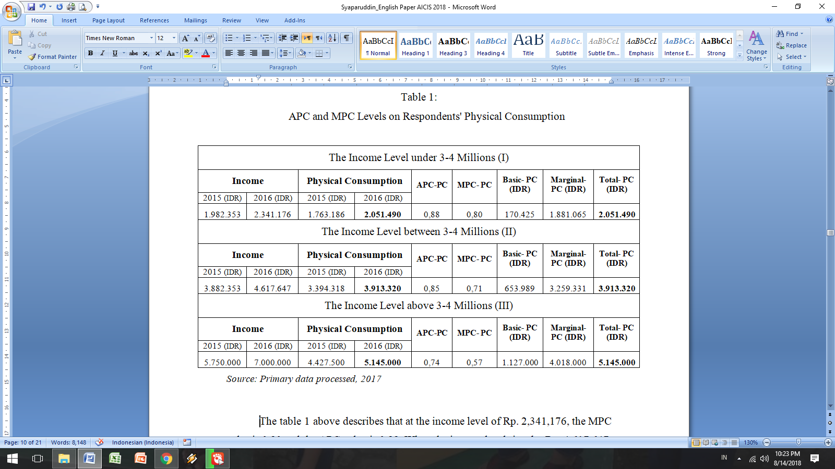
APC and MPC Levels on Respondents' Physical Consumption

The table 1 above describes that at the income level of Rp. 2,341,176, the MPC value is 0.80 and the APC value is 0.88. When the income level rises by Rp. 4,617,647, the MPC value dropped to 0.71 and the APC value also dropped to 0.85. When the income level rises by Rp. 7,000,000, the MPC value dropped again to 0.57 and the APC value also dropped to 0.74.
The description above indicates that the MPC value on the respondents’ physical consumption is smaller when their income increases. It means that the increase in their physical consumption does not increase even though their income continues to increase. This indicates that if they are more prosperous and fair, the portion of additional income used for physical consumption is not increased, so their ability to save increases. If so, their ability to provide investment funds needed in the long-term economic development also increases. Thus, the MPC level on physical consumption for higher-income respondent group, has a lower MPC level than the lower-income respondent group.
While the APC level also decreases even though their average consumption is constant because their income rises. The APC level is used to determine the comparison ratio between the level of physical consumption used by respondents at various levels of the income they have with their own income level. On this basis, it is implicitly understood that the funds spent by the respondents for physical consumption remain steady even though their income level rises. This means that the average level of physical consumption has been stable and not added even though the respondents have an opportunity and funds that can be used to increase it because of their rising income levels. However, the funds are prepared f or savings, so they have the ability to prepare investment funds needed for long-term economic development.
Second, the calculation results of the APC and MPC levels on respondents’ zakat maal payment, can be presented in the following table:
Table 2:
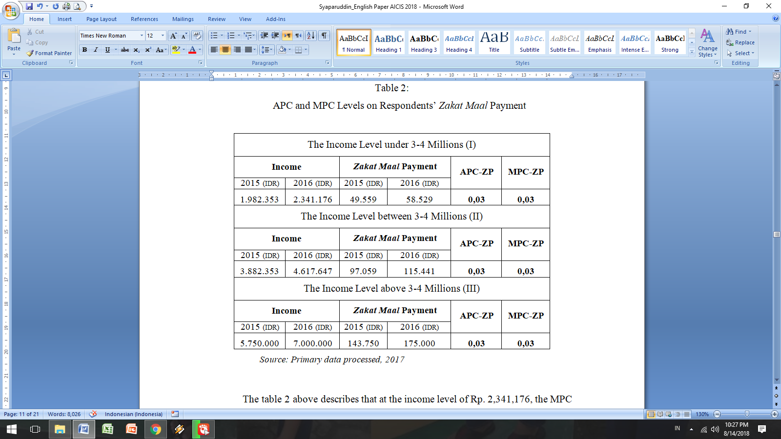
APC and MPC Levels on Respondents’ Zakat Maal Payment

The table 2 above describes that at the income level of Rp. 2,341,176, the MPC value is 0.03 and the APC value is also 0.03. When the income level rises by Rp. 4,617,647, the MPC value was fixed at 0.03 and the APC value was also fixed at 0.03. When the income level rises by Rp. 7,000,000, the MPC value was fixed at 0.03 and the APC value was also fixed at 0.03.
The description above indicates that the MPC and APC levels on respondents’ zakat maal payment at each level of income they have is the same, constant. It means that zakat maal payment for them is an obligation that has been established in Islam and cannot be contested anymore, therefore the zakat maal payment for them, is an obligatory to be carried out properly and correctly. Thus, if the respondents have fulfilled the requirements to pay zakat maal, they will fulfill it properly and correctly.
Third, the calculation results of the APC and MPC levels on respondents’ worship consumption, can be presented in the following table:
Table 3:
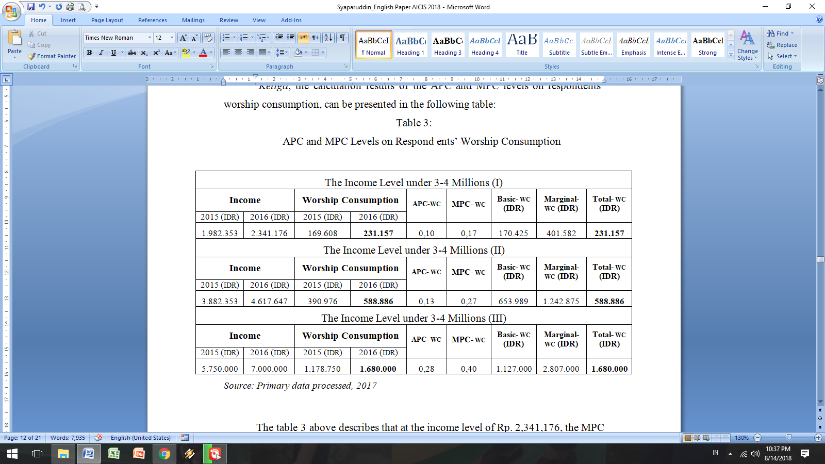
APC and MPC Levels on Respondents’ Worship Consumption

The table 3 above describes that at the income level of Rp. 2,341,176, the MPC value is 0.17 and the APC value is 0.10. When the income level rises by Rp. 4,617,647, the MPC value rose to 0.27 and the APC value also rose to 0.13. When the income level rises by Rp. 7,000,000, the MPC value rose again to 0.40 and the APC value also rose to 0.28.
The description above indicates that the MPC value on consumption of worship (other than zakat maal) of respondents is greater when their income increases. It means thar the increase in consumption of their worship besides zakat maal is more increasing if their income continues to increase. This indicates that if they are increasingly prosperous and fair, the portion of the increase in income used for consumption of worship will also increase. This means that respondents like to worship.
While the APC value also increased. The APC level is used to determine the level of worship consumption spent by respondents at the level of income they have. On this basis, it is implicitly understood that the funds spent by respondents for their worship consumption also rises. This means that the average level of consumption of their worship besides zakat maal always increases because they see worship as one of the basic needs in their lives, especially in the spiritual aspect.
Fourth, the calculation results of the comparison between the portion of personal basic consumption, and the portion of worship one of respondents at each level of income they have, can be presented in the following table:
Tabel 4:
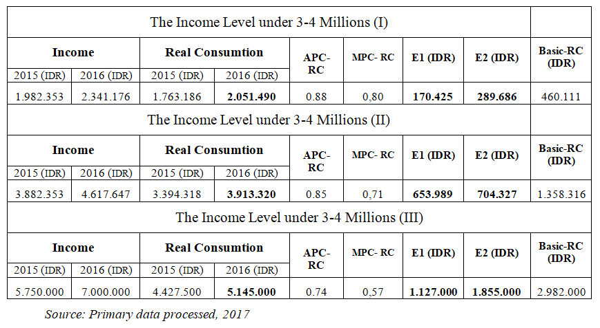
Comparison of Personal and Worship Basic Counsumtion of Respondents

The table 4 above describes about: First, at the income level of Rp. 2,341,176, the MPC value is 0.80 and the APC value is 0.88. When the income level rises by Rp. 4,617,647, the MPC value dropped to 0.71 and the APC value also dropped to 0.85. When the income level rises by Rp. 7,000,000, the MPC value dropped again to 0.57 and the APC value also dropped to Rp. 0.74. Second, at the income level of Rp. 2,341,176, the E₁ value is Rp. 170,425 and the E₂ value is Rp. 289,686. When the income level rises by Rp. 4,617,647, the E₁ value rose to Rp. 653,989 and the E₂ value also rose to Rp. 704,327. When the income level rises by Rp. 7,000,000, the E₁ value went up to Rp. 1,127,000 and the E₂ value also rose to Rp. 1,855,000.
In relation to the MPC and MPC levels in the description above, it can be explained that the MPC value on the basic consumption of respondents is smaller when their income increases. It measn that the increase in their personal basic consumption does not increase even though their income rises. This indicates that if they are more prosperous and fair, the portion of their additional income used in personal basic consumption is not added so that the portion is smaller than the portion of their worship basic consumption because they prioritize the interests and activities of worship.
While the APC value also decreased, it means that the average of their personal basic consumption is fixed even though their income rose. The APC level is used to determine the comparation ratio between the amount of funds for their personal basic onsumption spent by respondents at various levels of income they have, with their income level. On this basis, it is implicitly understood that the funds spent by respondents on their personal basic consumption are not added because they considered them stable even though their income level rises. This means that they allocate a greater portion of funds on their worship basic consumption than their personal basic consumption even though there are opportunities and funds that can be used to increase their personal basic consumption because of their rising income level. However, the funds are prepared for the interests and activities of worship.
In relation to the E₁ and E₂ levels in the description above, it can be explained that the portion of funds prepared by respondents for their worship basic consumption is greater than the one for their personal basic consumption. When their income level is Rp. 2,341,176, the E₂ value is greater than the E₁value (E₂, Rp. 289,686> E₁, Rp. 170,425). When their income level rises by Rp. 4,617,647, the E₂ value is also greater than the E₁ value (E₂, Rp. 704,327> E₁, Rp. 653,989). When their income level rises by Rp. 7,000,000, the E₂ value is also greater than the E₁ value (E₂, Rp. 1,855,000> E₁, Rp. 1,127,000). It means that the expenditure size of assets done by the respondents has already accorded with the objectives of Islam that the life is not only in the world, but also the life after life in this world. Assets are not a goal, but as a means of attaining maslahah.

Discussion
There are three important points from the analysis results above which will be discussed below. They are: First, the APC value > MPC value on physical consumption and worship one of respondents for all levels of their income. This can be interpreted that their physical consumption is not added even though their income continues to increase. If they are more prosperous and fair, the portion of their marginal income used for their physical consumption is not increased, so they have an ability to save their money. Whereas in matters of worship (other than zakat maal), their consumption is always increasing. It means that if they are increasingly prosperous and fair, the portion of their marginal income used for their worship consumption will also increase because they like worshiping very much.
But it should be underlined that the spending level on physical consumption of each respondent as an individual as explained by Jafar Aras, is not the same size. One respondent is different from another. Likewise, their spending on their physical consumption a year ago is not the same as their current one, because the physical needs of each respondent can increase from time to time. Thus, the size of their spending on physical consumption depends on many factors such as the amount of their income, the number of their family members and their age, the price level of goods and services, their social status including the level of education, social environment and their way of managing finances.
For their worship activities other than zakat maal, respondents' consumption will increase if their income also rises. This indicates that if they are increasingly prosperous and fair, the portion of their marginal income used for worship consumption will also increase. This means that the respondents like to worship.
Jafar Aras explained that respondents' consumption, both physical and worship consumption, has been guided by the Koran, namely they spent some of their money from their income based on the Koran, one of them is stated in Surah al-Baqarah (2): 267:

Hai orang-orang yang beriman, nafkahkanlah (di jalan Allah) sebagian dari hasil usahamu yang baik-baik dan sebagian dari apa yang kami keluarkan dari bumi untuk kamu. dan janganlah kamu memilih yang buruk-buruk lalu kamu menafkahkan daripadanya, padahal kamu sendiri tidak mau mengambilnya melainkan dengan memincingkan mata terhadapnya. dan Ketahuilah, bahwa Allah Maha Kaya lagi Maha Terpuji.

(O you who have believed, spend from the good things which you have earned and from that which We have produced for you from the earth, and do not aim toward the defective therefrom, spending [from that] while you would not take it [yourself] except with closed eyes, and know that Allah is Free of need and Praiseworthy).
This verse tells us to spend some of the assets owned from the income obtained. It is implicitly understood that this verse tells us to continue to work and try to produce something. In fact, giving an infaq contains motivation to work and earn. However, work and income derived from the results of sustainable business based on local wisdom must be guaranteed halal. So the ways that are not lawful, wrong with others, and practices that are not fair, will have a negative impact on life. In this framework, working is not solely about how to get as much profit as possible, but how to work and earn income from God's blessings.
In Islamic tradition being practiced in Sengkang as expressed by Jafar Aras that meeting the needs of things that are very urgent should not be excessive because this will have implications on respondents’ ways to work and shop. He further explained that the size was not in how much they have gained, but in the value of blessings contained in it. On this basis, it can be understood that the abundant wealth is not a measure of wealth for respondents, but how that wealth can give meaning to their psychology. In harmony with this, Rasulullah saw. said (H.R. Imam Bukhari from Abu Hurairah):
لَيْسَ الْغِنىَ عَنْ كَثْرَةِ الْعَرَضِ وَلٰكِنَّ الْغِنَى غِنَى النَّفْسِ
This hadith indicates that the size of the wealth is not a large amount of assests. On this basis, the thing that was done by respondents said Jafar Aras, was to harmonize the needs with their income. The most crucial problem for them according to Jafar Aras, is how to balance income with their expenses, because in general the need is greater than the income.
In connection with the above, the circle philosophy is very relevant to contemplate, namely the large and small circle if their degrees are calculated, they will make no difference, each has 360 degrees. It means that the large and small income are no longer an issue, but the important thing is the blessing of the income itself. That blessing is if what is owned can be useful to meet the needs and it gives happiness in this world, and God willing in the hereafter. For example, someone who has a low income (small circle) might enjoy barbering under the tree at a low-cost instead of trimming his hair in a starry salon as done by the people with very large income (big circle). People like this are able to align their expenses with their income so they don't feel that they are constantly lacking. However, this can stimulate them to commit fraud.
Second, the APC and MPC values on the zakat maal payments of respondents for all their income levels are the same, constant. It is interpreted that the zakat maal payment of respondents is an obligation that has been established in Islam and cannot be contested, therefore the zakat maal payment for them is obligatory to be done properly and correctly. Thus, if the respondents have fulfilled the requirements to pay zakat maal, they will do it properly and correctly.
H. Amiruddin said that the respondents pay zakat maal because they are always guided to pay zakat maal. They are always taught about the wisdom of paying zakat maal that:
- Paying zakat maal means thanking Allah's blessings. The blessings that are grateful for, promised by God will be added.
- Wealth collected by someone, not necessarily from the results of his own labor and sweat, but can also be the result of the labor of the workers who work for him. Therefore, he must share his wealth with the poor and the others of asnaf.
- Zakat maal makes the relationship between the Rich and the Poor become harmonious. Get along well and help each other.
- Zakat maal educates people to be generous. Humans are usually miserly, being miserly is hated by God. Zakat maal avoids us from being miserly.
- Among thieves or robbers who are caused by poverty. Zakat maal is a safety network that can reduce crime caused by economic factors.
Third, the E₁ < E₂ values on the basic consumption of respondents for all their income levels. This can be interpreted that if the respondents are more prosperous and fair, the portion of their marginal income used on their personal basic consumption, is not added so that its portion is smaller than the portion of the one for the activities and interests of worship. However, they still pay close attention to the two types of basic consumption mentioned above with only a different portion. Because both are basic needs for them every day. Thus, it can be ascertained that respondents' consumption behavior is in accordance with the objectives of Islam to achieve maslahah.
This is in accordance with Jafar Aras's statement that the two types of basic consumption are used to realize the five objectives of the Shari'a, namely to maintain the religion, soul, mind, descent and honor. Furthermore Jafar Aras explained that to realize the five objectives of sharia, respondents were disciplined in keeping the priority scale of the needs, in accordance with the income they earned. Even though they have been able to meet the needs of their complementaries, Islam still does not advocate, even forbid an exaggerated and luxurious spending because both can bring damage and destruction.
In harmony with the above, Mannan explained that human needs can be categorized into three main things, namely: Primary needs (daruriyah), secondary needs (hajiyyah), and tertiary needs (tsaniyyah). Primary needs according to Mannan are needs related to a person's life and death, such as the need for oxygen, food and drinks. Humans must continue to strive to maintain their lives by fulfilling their primary needs to the extent needed, and not exaggerating. While secondary needs according to Mannan, are the needs needed to overcome difficulties, but not to threaten life if it is not fulfilled. When eating and drinking is a primary human need, the instruments used to provide something ready to eat are categorized as secondary needs. Mannan further explained that tertiary needs are accessories, complementary, and add value to primary and secondary fulfillment. For example, the food served on the dining table with good service and good manners. The food itself is a primary need, cooking utensils and food serving containers are secondary needs, and good wishes and manners are tertiary needs.
The three types of needs mentioned above, namely the primary needs (daruriyyah), the secondary needs (hajiyyah), and the tertiary needs (tahsiniyyah) must be oriented towards the purpose of human life as referred to in Surah adz-Dzariyat (51): 56, namely worship to Allah swt. This is important to say, because fulfilling needs, especially tertiary needs, often plunges humans into excessive luxury if their orientation is not to the perfection of worship and moral glory.
However, in the personal life and worship of respondents as expressed by Jafar Aras that there are tertiary needs that must be considered, for example using perfume, pleasing appearance, and various accessories that are common in culture and do not conflict with Islamic teachings. Thus, if they use prevalent jewelries as long as they do not conflict with Islamic teachings, they are included in the category of tertiary needs that are justified
Conclution
The sustainable business financing in BMT As'adiyah Sengkang developed from the buginese humanist paradigm is a financial business based on Human Development, and a real business that cares for the environment and social based on Growth with Equity. The financial business based on Human Development in BMT As'adiayah Sengkang is providing a sustainable working capital financing with the principle of musharakah, mudharabah, and murabahah to the micro and small traders in traditional markets, the street vendors, the home industry businesses, the farmers, and the others. Whereas the real businesses based on Growth with Equity in BMT As'adiayah Sengkang, is the establishment of productive businesses that can absorb a large number of workers with a profit-sharing-based payroll system for the environment care, and providing a sustainable working capital to the poors with the principles of Qardul Hasan, and also a revolving capital to them from ZIS funds collected for the social care.
The analysis results showed that the business model can actually improve the welfare level of local community. This means that BMT As'adiyah Sengkang can position itself as a capable and credible Islamic microfinance institution in improving the welfare level of local community so that they can contribute greatly to increasing the regional GDP of Wajo Regency.
REFERENCES
Abbas, Irwan, “Pappaseng: Kearifan Lokal Manusia Bugis Yang Terlupakan” [Classic Massage: the Forgotten Buginese Local Wisdom], Journal of Sosiohumaniora, Volume 15 No. 3 November 2013, pp. 278-281.
BMT As’adiyah Sengkang, “Profile of BMT As'adiyah Sengkang’, Internal Document of BMT As’adiyah Sengkang, 2015.
Departemen Agama RI, Al-Qur’an dan Terjemahanya, Cet. 10 [Ministry of Religion of the Republic of Indonesia, Al-Qur'an and its Translation], Bandung: Diponegoro, 2003.
Huda, Nurul, et.al., Ekonomi Makro Islam [Islamic Macro Economics] (Jakarta: Kencana, 2013.
Indonesian Central Statistics Agency, Indonesia in Figure 2017, Jakarta: BPS, 2017.
Indonesian Satistics -South Sulawesi Province, “Proverty”, Cited from sulsel.bps.go.id, Accessed on March 11, 2017.
Ismail, Verni Yuliaty, et.al, “The Optimization of Human Resource’s Performance in Islamic Microfinance Institutions Through Job Analysis and Competency Model”, Asian Journal of Technology Management, 01 July 2015, Vol.8 (1), pp. 56-67. https://doi.org/ 10.12695/ajtm.2015.8.1.6.
Mannan, M. Abdul, “The Behaviour of The Firm and Its Objective in an Islamic Framework”, in Readings in Microeconomics: An Islamic Perspektif, Malaysia: Longman, 1992.
Nashir, Haedar, “Menggali Kearifan Lokal dalam Menghalau Kerakusan” [Exploring Local Wisdom in Avoiding Greed], Cited from http://www.republika.co.id, Accessed on March 10, 2017.
Solberg, Eric J., Microeconomics for Business Decisions, Toronto, D.C. Health and Company, 1992.
Sabirin dan Dini Ayuning Sukimin, “Islamic Micro Finance Melati: Sebuah Upaya Penguatan Permodalan bagi Pedagang Pasar Tradisional” [Islamic Micro Finance of Melati: an Effort to Strengthen Capital for Traditional Market Traders], Economica: Journal of Islamic Economics, 01 October 2017, Vol.8 (1), pp.27-53. https://doi.org/10.21580/economica.2017.8.1.1824.
Sabiti, Mustica Bintang dan Jaenal Effendi, "Islamic Micro Finance and Its Impact on Poverty Reduction of Two Village Models in Bogor, Indonesia ", Signifikan: Jurnal Ilmu Ekonomi, 01 February 2017, Vol.6 (1), pp. 87-102. https://doi.org /10.15408/sjie.v6i1.4337.
Samad, Mohammed Abdul, "Islamic Micro Finance: Tool for Economic Stability and Social Change", Humanomics, 2014, Vol. 30 Issue: 3, pp.199-226. https://doi. org/10.1108/H-12-2013-0085.
Syaparuddin, “Revitalizing Buginese Local Wisdom in The Development of Local Economy: Constructing Paradigm and Models”, IOP Conference Series: Earth and Environmental Science, Volume 175, Conference 1, 2018, https://doi.org/ 10.1088/ 1755-1315/175/1/012142
Pratiwi, Niken, et.al, “Analisis Implementasi Pembangunan Berkelanjutan di Jawa Timur” [Analysis of Implementation of Sustainable Development in East Java], Journal of Development Economics, ISSN (P) 1412-2200, E-ISSN 2548-1851, Vol. 18, No 1, Maret 2018, p. 3.
Wardiwiyono dan Sartini, “Internal Control System for Iislamic Micro Financing: an Exploratory Study of Baitul Maal wat Tamwil in the City of Yogyakarta Indonesia”, International journal of Islamic and Middle Eastern finance and management, 2012, Vol.5(4), pp.340-352. https://doi.org/10.1108/17538391211 282836.
Yin, Robert K., Case Study Research, New Delhi: SAGE Publications, 1994.
Zaini, M. dan Agus Tri Darmawanto, “Implementasi Pembangunan Berkelanjutan Berwawasan Lingkungan (Studi Pada Kelurahan Lempake Kecamatan Samarinda Utara Kota Samarinda)” [Implementation of Environmentally Sustainable Development (Study on Lempake Village, North Samarinda District, Samarinda City], Journal of Development Economics, ISSN (P) 1412-2200, E-ISSN 2548-1851, Vol. 15, No 2 November 2015.

Indonesian Central Statistics Agency, Indonesia in Figure 2017 (Jakarta: BPS, 2017), pp. 34-35.
The economy of the three sectors consists of household, company and government. In relation to the provision of employment, the household as the owner of the factors of production, it is the provider of labor, while the company as the user of factors of production, it is the user of labor, and the government is the regulator, the user, as well as the provider of labor. See Eric J. Solberg, Microeconomics for Business Decisions (Toronto, D.C. Health and Company, 1992), pp. 40-41.
BMT As’adiyah Sengkang, “Profile of BMT As'adiyah Sengkang’, Internal Document of BMT As’adiyah Sengkang, 2015, p. 5.
DOI (Digital Object Identifier) is a unique alpha-numeric arrangement established by the International DOI Foundation, which serves to identify content and provide fixed links on the internet. Publisher sets a DOI when articles are published and made electronically.
Sabirin dan Dini Ayuning Sukimin, “Islamic Micro Finance Melati: Sebuah Upaya Penguatan Permodalan bagi Pedagang Pasar Tradisional” [Islamic Micro Finance of Melati: An Effort to Strengthen Capital for Traditional Market Traders], Economica: Journal of Islamic Economics, 01 October 2017, Vol.8 (1), pp.27-53. https://doi.org/10.21580/economica.2017.8.1.1824.
Mustica Bintang Sabiti dan Jaenal Effendi, "Islamic Micro Finance and Its Impact on Poverty Reduction of Two Village Models in Bogor, Indonesia ", Signifikan: Jurnal Ilmu Ekonomi, 01 February 2017, Vol.6 (1), pp. 87-102. https://doi.org/10.15408/sjie.v6i1.4337.
Verni Yuliaty Ismail, Efendy Zain, dan Zulihar, “The Optimization of Human Resource’s Performance in Islamic Microfinance Institutions Through Job Analysis and Competency Model”, Asian Journal of Technology Management, 01 July 2015, Vol.8 (1), pp. 56-67. https://doi.org/10.12695/ ajtm.2015.8.1.6.
Mohammed Abdul Samad, "Islamic Micro Finance: Tool for Economic Stability and Social Change", Humanomics, 2014, Vol. 30 Issue: 3, pp.199-226. https://doi.org/10.1108/H-12-2013-0085.
Wardiwiyono dan Sartini, “Internal Control System for Iislamic Micro Financing: an Exploratory Study of Baitul Maal wat Tamwil in the City of Yogyakarta Indonesia”, International journal of Islamic and Middle Eastern finance and management, 2012, Vol.5(4), pp.340-352. https://doi.org/ 10.1108/17538391211282836.
Satistics Indonesia-South Sulawesi Province, “Proverty”, Cited from sulsel.bps.go.id, Accessed on March 11, 2017.
Niken Pratiwi, dkk, “Analisis Implementasi Pembangunan Berkelanjutan di Jawa Timur” [Analysis of Implementation of Sustainable Development in East Java], Journal of Development Economics, ISSN (P) 1412-2200, E-ISSN 2548-1851, Vol. 18, No 1, Maret 2018, p. 3.
M. Zaini dan Agus Tri Darmawanto, “Implementasi Pembangunan Berkelanjutan Berwawasan Lingkungan (Studi Pada Kelurahan Lempake Kecamatan Samarinda Utara Kota Samarinda)” [Implementation of Environmentally Sustainable Development (Study on Lempake Village, North Samarinda District, Samarinda City], Journal of Development Economics, ISSN (P) 1412-2200, E-ISSN 2548-1851, Vol. 15, No. 2 November 2015, p. 26.
Niken Pratiwi, dkk, “Analisis Implementasi Pembangunan Berkelanjutan di Jawa Timur” [Analysis of Implementation of Sustainable Development in East Java], p. 3.
Haedar Nashir, “Menggali Kearifan Lokal dalam Menghalau Kerakusan” [Exploring Local Wisdom in Avoiding Greed], Cited from http://www.republika.co.id, Accessed on March 10, 2017.
Irwan Abbas, “Pappaseng: Kearifan Lokal Manusia Bugis Yang Terlupakan” [Classic Massage: the Forgotten Buginese Local Wisdom], Journal of Sosiohumaniora, Volume 15 No. 3 November 2013, p. 279.
Irwan Abbas, “Pappaseng: Kearifan Lokal Manusia Bugis Yang Terlupakan” [Classic Massage: the Forgotten Buginese Local Wisdom], p. 280.
Irwan Abbas, “Pappaseng: Kearifan Lokal Manusia Bugis Yang Terlupakan” [Classic Massage: the Forgotten Buginese Local Wisdom], p. 281.
Syaparuddin, “Revitalizing Buginese Local Wisdom in The Development of Local Economy: Constructing Paradigm and Models”, IOP Conference Series: Earth and Environmental Science, Volume 175, Conference 1, 2018, p. 3. https://doi.org/10.1088/1755-1315/175/1/012142.
Syaparuddin, “Revitalizing Buginese Local Wisdom in The Development of Local Economy: Constructing Paradigm and Models”, p. 4.
Nurul Huda, et.al., Ekonomi Makro Islam [Islamic Macro Economics] (Jakarta: Kencana, 2013), p. 40.
Nurul Huda, et.al., Ekonomi Makro Islam [Islamic Macro Economics], p. 41.
Nurul Huda, et.al., Ekonomi Makro Islam [Islamic Macro Economics], p. 42.
Robert K. Yin, Case Study Research (New Delhi: SAGE Publications, 1994), p. 124.
The Interview results with Jafar Aras, Management of BMT As'adiyah Sengkang, Sunday, October 1, 2017 at 10.30-12.00 (Central Indonesian Time) at BMT As’adiyah Sengkang.
The Interview results with Jafar Aras, Management of BMT As'adiyah Sengkang, Sunday, October 1, 2017 at 10.30-12.00 (Central Indonesian Time) at BMT As’adiyah Sengkang.
Departemen Agama RI, Al-Qur’an dan Terjemahanya, Cet. 10 [Ministry of Religion of the Republic of Indonesia, Al-Qur'an and its Translation] (Bandung: Diponegoro, 2003), p. 35.
The Interview results with Jafar Aras, Management of BMT As'adiyah Sengkang, Sunday, October 1, 2017 at 10.30-12.00 (Central Indonesian Time) at BMT As’adiyah Sengkang.
The Interview results with Jafar Aras, Management of BMT As'adiyah Sengkang, Sunday, October 1, 2017 at 10.30-12.00 (Central Indonesian Time) at BMT As’adiyah Sengkang.
The Interview results with H. Amiruddin, Management of BMT As'adiyah Sengkang, Sunday, October 2, 2017 at 09.00-11.00 (Central Indonesian Time) at BMT As’adiyah Sengkang.
The Interview results with Jafar Aras, Management of BMT As'adiyah Sengkang, Sunday, October 1, 2017 at 10.30-12.00 (Central Indonesian Time) at BMT As’adiyah Sengkang.
M. Abdul Mannan, “The Behaviour of The Firm and Its Objective in an Islamic Framework”, in Readings in Microeconomics: An Islamic Perspektif (Malaysia: Longman, 1992), pp. 107-108.
The Interview results with Jafar Aras, Management of BMT As'adiyah Sengkang, Sunday, October 1, 2017 at 10.30-12.00 (Central Indonesian Time) at BMT As’adiyah Sengkang.

